National College of Ireland

BSc in Computing

2018/2019

Colin Allen

X15540607

X15540607@student.ncirl.ie

An Analysis of the Dublin Rental Market

Technical Report



**Table of Contents**

Executive Summary 3

1 Introduction 4

1.1 Background 4

1.2 Aims 4

1.3 Technologies 4

1.4 Structure 4

2 System 5

2.1 Requirements 5

2.1.1 Functional requirements 5

2.1.2 Data requirements 5

2.1.3 User requirements 5

2.1.4 Environmental requirements 5

2.1.5 Usability requirements 5

2.2 Design and Architecture 5

2.3 Implementation 5

2.4 Graphical User Interface (GUI) Layout 5

2.5 Testing 6

2.6 Unit – System – Integration – End User testing 6

2.7 Evaluation 6

3 Conclusions 7

4 Further development or research 8

5 References 9

6 Appendix 10

6.1 Project Plan 10

6.2 Monthly Journals / Meeting Minutes 10

6.3 Other Material Used 10

# Executive Summary

This project was compiled for the BSc (Honours) in Computing program, at the National College of Ireland. The purpose of my project is to analyse the Dublin rental market through the use of the listings on Daft.ie. The result of the project will identify different areas of the rental market based on location in the city and analyse multiple statistics surrounding the rental market and help potential tenants make decisions on entering the rental market. This information from Daft.ie will then be compared to other related data to extract further understanding of the Dublin rental market and to gain an analytic understanding of why the cost of rent has risen dramatically in recent years.

This technical report will set out my aims, ambitions and requirements to analyse the Dublin rental market. To achieve those aims programming languages such as R and Python will be used to retrieve data from relevant sources, clean, transform and evaluate the data to gain knowledge on the rental market. The Knowledge Discovery and Data Mining (KDD) methodology will be used.

The system for the statistical analysis consists of a database for storing and analysing data retrieved from multiple data sources. Data extraction and Pre-processing will be performed in Python and the data will be analysed using R. Finally, the results of the system will be visualized for end-user consumption.

# Introduction

## Background

The rental market in Dublin city centre has become a crisis. With prices skyrocketing and many people struggling to find a place to live at a reasonable cost. According to a report by Daft.ie, the average monthly rent nationwide during the final quarter of 2017 was €1,227. This issue is particularly important to young adults looking to enter the rental market or as Mature students who are already struggling affording a place to live.

This has been in the news regularly over the past few years with many of my classmates and friends lamenting the high cost and low quality of potential living conditions. Tenants paying a high cost to live in poor conditions, even far removed from the city centre – where they’ll have to endure tedious and monotonous public transportation every morning and evening during rush hour. Many of my friends that are fellow students are considering leaving the country as soon as possible, due to the lack of living space, and the space that is there is at a hugely inflated cost. That was the inspiration for this project, there is a multitude of data on daft.ie with over 80% of the countries listings, however this is way too much data for any one person to analyse on their own. So if a data model to analyse all of this data and then report the findings in an way that is easily consumed, It could benefit all of those who have to enter the Dublin rental market.

## Aims

The objective of this project is to develop a system that analyses the property rental market in Dublin, Ireland. Identifying areas of significantly high cost and to gain an understanding of this inflated cost, and the possible reasons for this cost. The following is a list of specific aims that will help achieve the overall objective:

**Aim 1:** The first project aim is to target data that would help the main objective of this project fulfilled. In order to source the appropriate data, A programmatic way of analysing the Dublin rental market must be achieved. This data is essential and required for this project.

**Aim 2:** All datasets will require Pre-processing in order to analyse the correct information for example, the datasets could be very large and contain unnecessary data for the purposes of my analysis, or the data could contain a large percentage of missing values which would require a strong understanding of the dataset to remove, or potentially replace those missing values.

**Aim 3:** Plotting the locations of all potential rental properties Dublin onto a map for a visual representation will be required for visualisation purposes.

**Aim 4:** The fourth aim will require further analysis using programming and data mining techniques, ideally machine learning techniques gained from semester two.

**Aim 5:** The final aim is building a report that documents the results of the project, visualizations and representations of the results demonstrated through a data visualization tool.

## Technologies

**R:**

R is a programming language and free software environment for statistical computing and graphics. R is used among statisticians and data miners for performing statistical and data analysis. This will be used heavily for Data cleansing and Exploring the data.

**Python:**

Python is an interpreted, high-level, general-purpose programming language. Python will be used for data extraction and data cleansing, pre-processing, and data analysis.

**RStudio:**

Rstudio is a free and open-source integrated development environment for the R programming language. Rstudio will allow me to write and manipulate data in the R programming language.

**Microsoft Excel:**

Microsoft Excel is a spreadsheet program created by Microsoft. It can be used to handle large data sets in comma separated values files (.csv). Microsoft Excel will be used to pre-process data, visualise data, and files will be extracted and loaded from different parts of the system in this .csv format.

**MySQL:**

MySQL is an open source relational database management system. MySQL allows for a database to be queried and for datasets to be stored. MySQL will be particularly useful for storing large amounts of data as holding too much data within RStudio can cause technical slowdown and crashes.

**Rshiny:**

Rshiny is a library in R that allows for the creation of web based interactable graphs, which will allow the graphs and findings to be displayed and interacted with by users on a website.

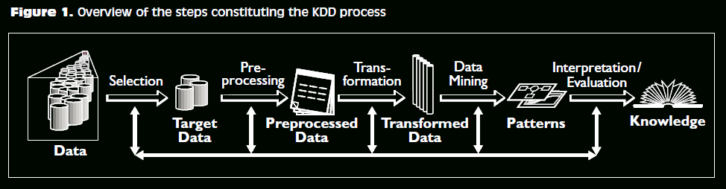

**Figure 1: Knowledge Discover in Database Diagram (KDD). [6]**

The entire project will follow one of the core data analytics methodologies; Knowledge discovery in databases (KDD). The KDD methodology follows a sequence of stages that are essential for the application of the methodology.

**Data selection:** Data selection focuses on ensuring that the acquired data set or data sets that are to be analysed will result in useful findings related to the chosen topic. Using data selection within my project, selecting appropriate datasets will be essential to completing the project aims and objectives. This will result in having acquired a target dataset.

**Pre-Processing:** The pre-processing of this target data is the next step in the methodology. This means cleansing of the data, detecting, correcting or removing corrupt or inaccurate data from the datasets or database. Pre-processing for the project will be accomplished in both R and Python. The result of this stage will be a dataset that has been cleansed and pre-processed.

**Transformation:** This phase will making use of Python and RStudio to load the data from the csv files or from a database such as MySQL, into RStudio so the data can be analyzed. This results in transformed data.

**Data Mining:** the data mining stage searches for patterns in the data that can become of interest to the aims and objectives of the project. Answering questions or assumptions that were held before the analysis took place and either confirming the answers to those questions, or in fact proving that those assumptions were in fact wrong. Machine Learning Algorithms can be used here to discover patterns within the data. From this stage the patterns that are inherent within the data are revealed to us.

**Interpretation/Evaluation:** The last stage of the methodology involves evaluating the discovered knowledge, given to us from the pattern recognition of the data mining stage. The result of applying this stage of the methodology will be applicable to our visualization aim, the results from this stage will be easily consumed by end-users through our visualization software, Tableau.

## Technical Details

The computer specifications available:

Macbook Pro 2017:

* macOS High Sierra 10.13.6
* 2.3GHz dual-core Intel Core i5, Turbo Boost up to 3.6GHz, with 64MB of eDRAM
* 8GB of 2133MHz LPDDR3 onboard memory
* 128GB Solid State Drive

Home Desktop PC:

* Windows 7
* Intel Core i7-7700HQ Quad Core Processor
* 16GB DDR4-2400MHz
* 1TB Hard Drive
* Nvidia GeForce GTX 1060 Graphics Card

# System Requirements

### Functional requirements

For the functional requirements of this project, the use cases that are needed for the projects functionality are outlined. In this case the researcher is the Data analyst and will show how the data is being accessed and how the KDD methodology will be followed.

The use cases are the most important functional requirements for accessing the data that is needed to make the project functional.

### Use Case Diagram

The following use case diagram will provide an overview of all functional requirements.

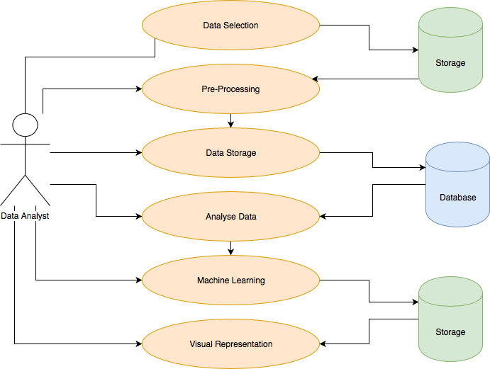

### Use Case Priority Table

The following priority table determines the meaning of each priority ranking associated with each Use Case

|  |  |
| --- | --- |
| **Priority 1** | Considered vital to the project |
| **Priority 2** | Also considered vital, but has viable alternatives |
| **Priority 3** | Not considered a must have but enhances the possibilities of analysis |

### Requirement 1: Data Selection and Extraction

**Description & Priority**

The data selection requirement is the first requirement. This is essential to the project and ranked Priority 1. Without data selection and extraction, the project is impossible.

**Use Case**

**Scope**

Selected data is extracted and downloaded, the data is stored in a database. Following the first phase of the KDD methodology.

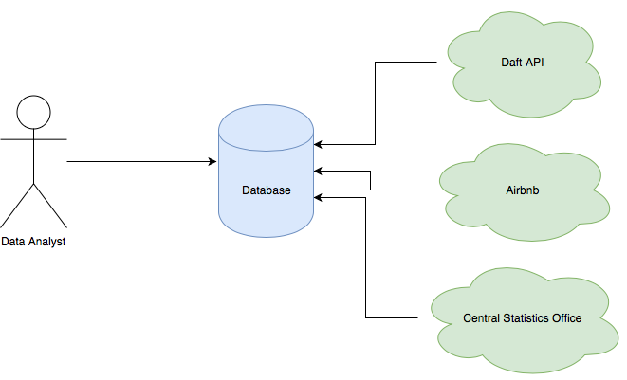

**Flow Description**

**Precondition:**

The Data analyst must have access to their email account and relevant website to download data.

The Python script to make HTTP requests to the daft API must be successfully created and run without interruption.

**Activation:** This use case begins when the Data analyst retrieves the data from the sources.

**Main Flow**

1. The Data analyst logs into the website to download the data to their device, this will be received in the csv format.
2. The DA activates the database to be able to receive data.
3. The DA runs the Python script and waits for it to finish.
4. The DA checks data integrity by opening the csv files and viewing the data extracted from the API in MySQL.
5. The data is now secured.

**Exceptional Flow**

1. Relevant webpages are down.
2. The Python script is interrupted due to technical error
3. The datasets are corrupted upon inspection

**Termination**

The Process of selecting, extracting and storing the data is complete, therefore the termination process occurs.

### Requirement 2: Pre-processing

**Description & Priority**

The Pre-Processing use case involves changing the dataset in such a way that will enable analysis to be performed on it. This process is ranked Priority 1.

**Use Case**

**Scope**

Pre-processed data enables the ability to perform an analysis, following the second phase of the KDD methodology.

**Use Case Diagram**

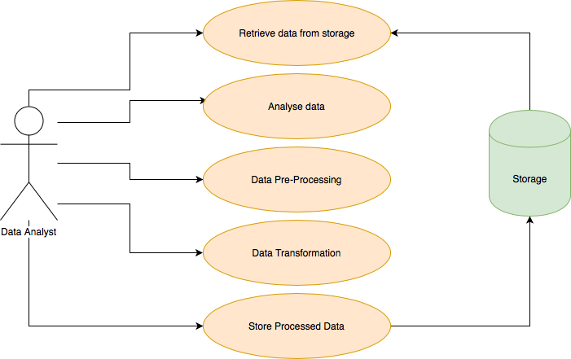

**Flow Description**

**Precondition:**

The Data must be accessible to the Data Analyst

**Activation:**

This use case beings when retrieval of the data use case terminates.

**Main Flow:**

1. The DA retrieves the data
2. The data is analyzed and cleansed
3. Pre-Processing of the data begins
4. Transformation of the data has occurred
5. The processed data is stored

**Exceptional flow:**

The required data cannot be retrieved

**Termination**

The pre-processing use case terminates hen the data is cleansed, transformed and stored securely.

### Requirement 3: Data Storage

**Description & Priority**

The data storage requirement involves storing the datasets within a database to ensure secure and accessible data. This is ranked priority 2.

**Use Case**

**Scope**

Development of a Database with tables to store the data.

**Use Case Diagram**

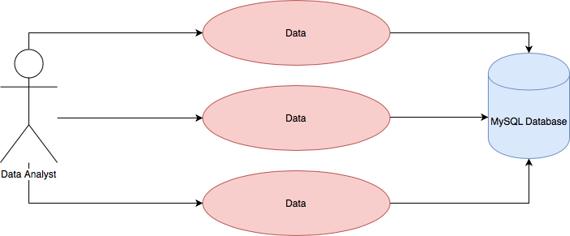

**Flow Description**

**Precondition:**

The data must be Pre-processed and Transformed to the correct format before it can be stored in a database.

**Activation**

Activation of the use case commences when the data is pre-processed and the pre-processing use case is terminated.

**Main flow**

1. The DA retrieves the data
2. The DA creates suitable tables and schema within the database to store said data
3. The data is stored within the database tables

**Alternative flow**

Alternative storage is viable, although unlikely.

**Exceptional flow**

Retreival of the pre-processed data is not possible.

**Termination**

The termination of this requirement occurs when the data is securely stored within the database.

**Post condition**

Data can be accessed while stored within the MySQL database.

### Requirement 5: analyze data

**Description & Priority**

The analyze data requirement is essential to the project and has a priority of 1. The analysis of the datasets is essential for revealing the inherent patterns that reside within the data, the revealing of these patterns is essential to achieving the aims set out for this project.

**Use Case**

**Scope**

Data is retrieved from the database and analysis is performed using programming scripts. Results are then stored.

**Use Case Diagram**

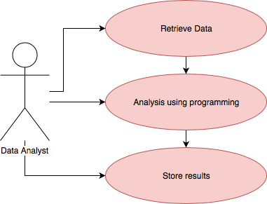

**Flow Description**

**Precondition**

The data must be stored within a database and accessed by the DA.

**Main Flow**

1. The DA retrieves the data from the database
2. The data is analyzed by using programming languages R & Python
3. Understanding of the results of the analysis are gained
4. The results of this understanding is saved

**Exceptional flow**

Retrieval of the data from the database is unsuccessful.

**Termination**

This use case terminates when the analysis is completed.

**Post Condition**

The data is stored within the database for future analysis, the results are stored securely.

### Requirement 5: Machine Learning

**Description & Priority**

The machine learning requirement is ranked priority 2. Although it is vital to explore the datasets and the result of the analysis of those datasets, machine learning isn’t the only viable option. The datasets will be run through Machine Learning Algorithms to discover patterns and comparisons between the datasets.

**Use Case**

**Scope**

Datasets are retrieved and prepared for Machine Learning. When preparation has completed, the data will be run through the Machine Learning Algorithm, and the results are analyzed and stored.

**Use Case Diagram**

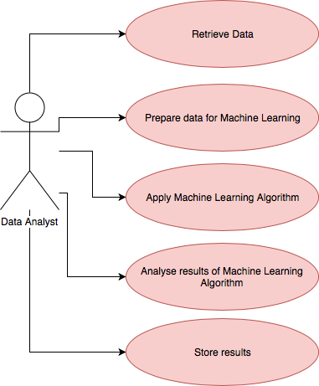

**Flow Description**

**Precondition:**

Data is retrievable by the DA.

**Activation:**

This use case activates when data retrieval terminates.

**Main flow**

1. The DA retrieves the data
2. The DA prepares the data for Machine Learning
3. Machine Learning Algorithm is applied to the data
4. Results are analyzed
5. Results are stored

**Exceptional flow**

The application of Machine Learning Algorithm are not possible.

**Termination**

This use case terminates when the results are stored.

### Requirement 6: Visualization and Representation

**Description & Priority**

Visualizations and Representation is the final requirement of this project, along with the final phase of the KDD methodology. This is ranked Priority 2, as it is vital to show the results of the analysis in an easily consumable way, there a many viable way to achieve this.

**Use Case**

**Scope**

Import analyzed data into the data visualization application, Visual representations can then be produced to ensure user friendly consumption of the results.

**Use Case Diagram**

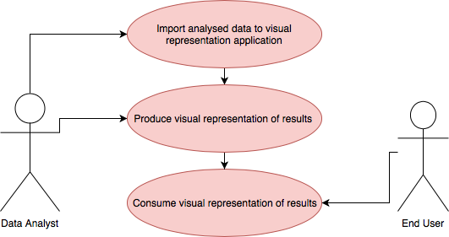

**Flow Description**

**Precondition:**

All analysis of the data are complete to create the final visualization for consumption by the end user.

**Activation:**

This use case beings when the other use cases have terminated and results are accessible by the DA.

**Main flow**

1. The analyzed data is imported into the data visualization application.
2. Final visualizations are produced by the DA.
3. Final visualizations are available to be consumed by end users.

**Exceptional flow**

Importing the data into the visualization application is not possible.

**Termination**

The use case terminates when the visualizations are complete and ready to be consumed by end users.

* 1. **Non-Functional Requirements**

### Security requirement

Security is an important requirement for the system. The data provided will be securely stored in a database hosted locally on a password protected computer. The Data analyst is the only user of the computer and will have full rights to the database which will be password protected. The system will be entirely offline which will secure it from any malicious online attacks.

### Availability requirement

Data will be available to the system for the duration of the project. The data required is available online and has already been stored on the system.

### Integrity requirement

The datasets will contain all attributes and values required to perform the analysis to gain insight on the topic

### User Requirements

The user requirements are that the data should be easily accessible and consumable by end users who require it.

### Application Programming Interfaces (API)

The main dataset being retrieved from the Daft.ie API doesn’t include latitude and longitude data, that means values from the dataset will be fed through a mapping API such as Google Maps to acquire this data, which will allow for better results and stronger visual representation of those results.

### Data requirements

Because my project is data analytics, the data requirements for this project are very important. The data must be cleaned and the data must be accurate for any value results to be confirmed.

## Design and Architecture

Below is the architecture of how the main flow of the project will work:

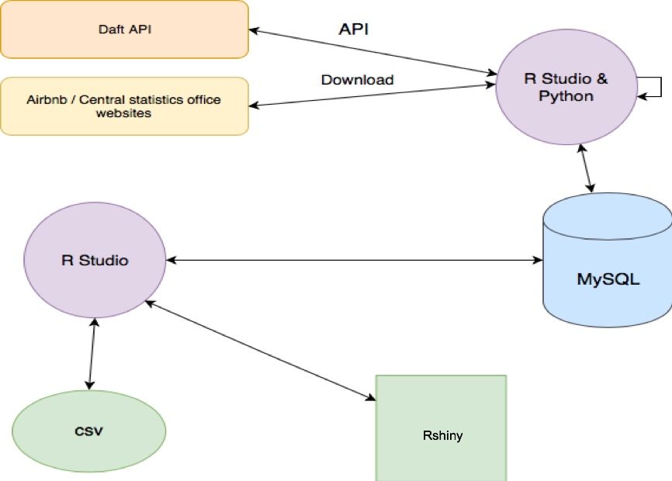

**Daft API:** This is the API that allows access to all of the listings on Daft.ie to be extracted with the use of Python, cleansed, preprocessed, and finally placed in MySQL Database.

**Airbnb / Central Statistics Office websites:** These websites host datasets that can be downloaded and extracted into a MySQL database using Rstudio.

**Rstudio & Python:** These are used for extraction and exploration of the data pulled from the data sources and are used to import the data into a MySQL database

**Rstudio:** From there the data is extracted from the Database with Rstudio to perform the analysis on the data stored in the Database.

**Csv/Rshiny:** Finally, the results from Rstudio are produced into a csv to easily be consumed by another system such as Rshiny.

### Data Selection

The first phase of the project was to select data that allow for an analysis of the Dublin rental market to be performed. This data was taken from multiple sources, the most useful being data retrieved from Daft.ie, which is the most popular property rental and sales website hosting most current listings. This data was extracted using an open source python based web-scraping API interface, transformed from python into a local MYSQL database, and finally exported as a .csv file to be read in Rstudio. [5]

After this, more data was downloaded from the central statistics office, and Airbnb. These were free to download and manipulate for data analysis. Also .csv.Files easily read into R.

**Daft:**

The data that could be extracted from each listing from daft was extensive, therefore the first stage of data selection actually begins when deciding which data was important, and which data was not. Multiple rounds of selecting certain parts of the data, and omitting other parts, only to later come back and retrieve data again and again from the API meant that this form of data gathering was consistently tested again and again. Ultimately a final dataset was decided on and from there further data analysis could be performed.

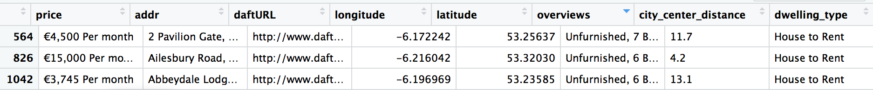

**Airbnb:**

Comparisons between the current Dublin rental market and Airbnb were apparent from the first day of this project, It is impossible to speak on the Dublin rental market and ignore the influence of a service like Airbnb. This dataset was easy to obtain as they host full, clean datasets on their website. However, the dataset contains a multitude of columns and rows, which in turn meant that data selection was more difficult, as knowing which features and aspects of this dataset that would lend themselves to an insightful analysis is unknown, and must be discovered.

**Central Statistics Office:**

Rental prices across the city have been recorded by the central statistics office from 2007 – 2017, this data can be accessed through their website. This data is what they use to perform their analysis and is the only dataset of the three to contain data over time. This is an important variable for Time Series Analysis.

### Data Preparation

The data preparation step used libraries dplyr, stringr, and tidyr to interact and manipulate the datasets. The datasets needed to be split and combined along different features to be usable for machine learning and exploratory purposes.

Initially the datasets were checked for NULL values, as empty values in the dataset would cause issues for machine learning and any graphs or analysis of the data that could be performed.

Although the mice library was attempted to impute missing values from the datasets, ultimately its usage was avoided and rows that contained NULL values on essential features were removed. Due to the low number of rows that contained NULL values, this was not much of an issue.

**Daft:**

The daft dataset had a lot of issues when first read into Rstudio that needed to be cleaned. Initially the Price column would contain values for per month or per week. This needed to be changed to a numerical value, for per month the text was removed and the value remained, and anywhere per week appeared, the text was removed and the cost was multiplied by 4. However, this lead to extreme outliers in the upper end of the dataset, as short term lettings that have a high weekly rent price, for example a 5 bedroom, 3 bathroom house, would have a monthly cost of 6000 – 8000, when in reality those listings were not available for long term renting. This is dealt with later in relation to outliers for data mining.

Furthermore, the address column needed to be split into different Dublin area codes, such as Dublin 1, Dublin 2, etc. This was done by extracting the area code form the address field and inserting a new column into the data, titled ‘Postcode’. The data could now be sub-set and identified based on its location within Dublin’s area code, which would help massively with visualisations, and acted as a strong predictor for machine learning models.

Additionally, a categorical column was added to the data to create tiers at different levels of cost, anything lower than 2000 considered to be “low”, between 2000 and 3000 to be considered “medium”, and anything over considered “high”. This allowed for variations in the dataset and to have an understanding of the different rental costs split throughout the data.

A column titled “Overviews” consisted of # of Bedrooms / Bathrooms information in a single column, this was split over two columns so data could be referenced and accessed easily, and used as a predictor for machine learning.

**CSO:**

The data acquired from the central statistics office was strange. Each row seemed to be an aggregate of multiple rental costs for an undefined area. For example, donnybrook had a rent cost of €1646, for houses of “All Property Type” and with a number of bedrooms of “All bedrooms”. While another row had a rent cost of €1199 for the same house type, “All Property Type”, with a number of bedrooms of “One bed”.

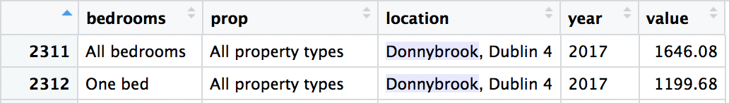

And this continued for many types. Donnybrook, Dublin 4 had 22 different entries, with varying values depending on whether it was “All bedrooms” Or “All Property Types”. After discussing this particular issue with my supervisor, It was decided that an aggregation of this data would lead to a cleaner and more understandable dataset, which could then be used for Time series analysis.

This new aggregated dataset reduced the amount of data, but it consolidated it into something useable, and considering there was already more than enough data available, it worked out better this way.

The Airbnb dataset had very little to do in terms of data manipulation, other than the selection of features, once selected the data was understandable and had few issues. A testament to Airbnb and their data analysis work.

#### Exploratory Analysis

Exploratory data analysis aims to: -

•  Produce questions regarding your data;

•  Examine visuals and transformations for feedback from your data;

•  Provide insights to aid in the understanding of the data.15

**Boxplots:**

Exploratory analysis began with some simple histograms and boxplots of the data, it is important to check if the data is normally distributed especially in relation to numerical variables, such as rent cost. Looking at the Histogram and Boxplot of the price feature, it can be seen that the data is not normal, and that there are some high-priced outliers at the top. This is definitely a result of high priced weekly rentals being multiplied by 4 to fit into our rent / per month model. The existence of this data points are fine, as long as they are found and made aware of.

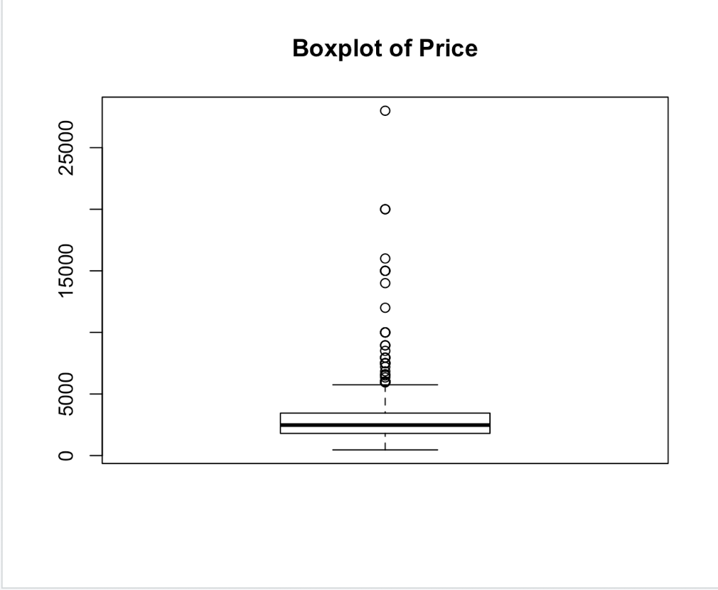

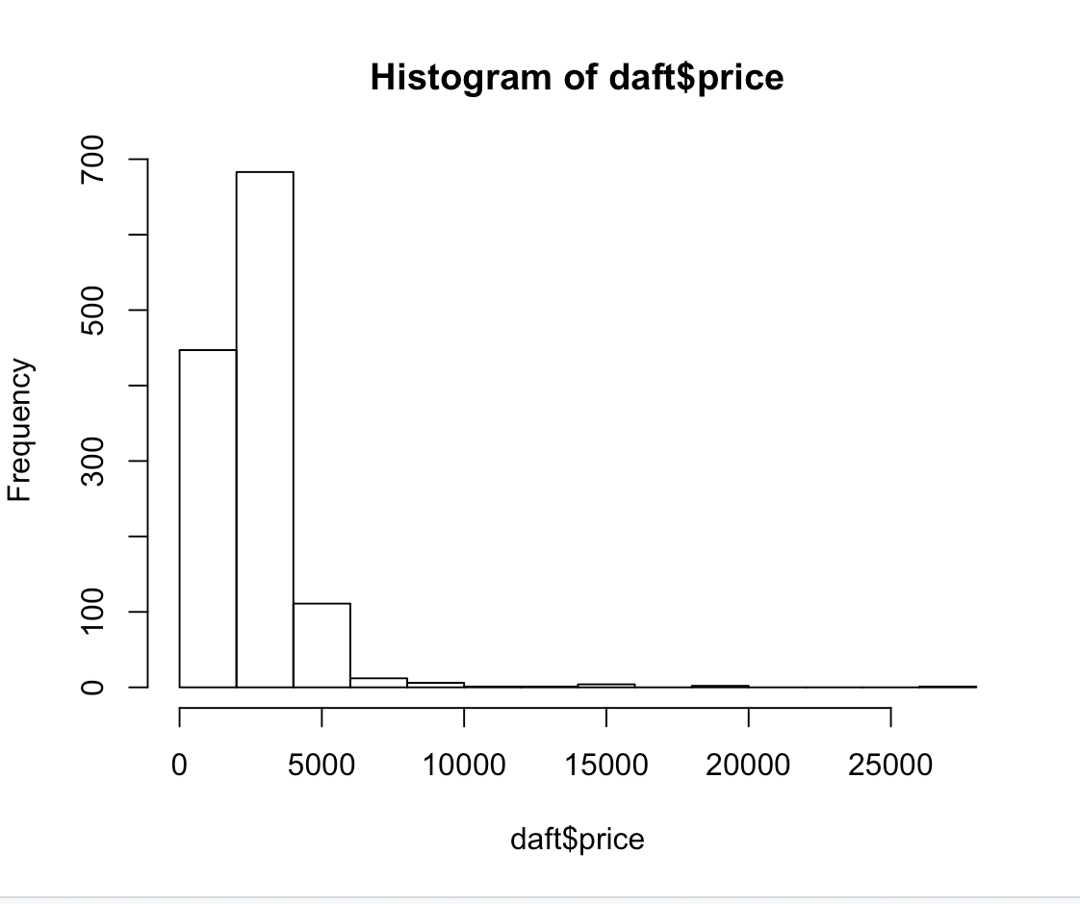

The data is positively skewed, with most of the values being to the left of the histogram. This, alongside the boxplot, shows that a number of outliers are skewing the data. This is a sign of non-normal data.

Another numerical variable found within the daft dataset is Distance, this is a measure of distance between the property and the city centre, measured in kilometres. A histogram of this data shows that a similar positive skew, Implying that most of the listings in the dataset are close to the city centre, with less property listings being added the further away from the city centre.

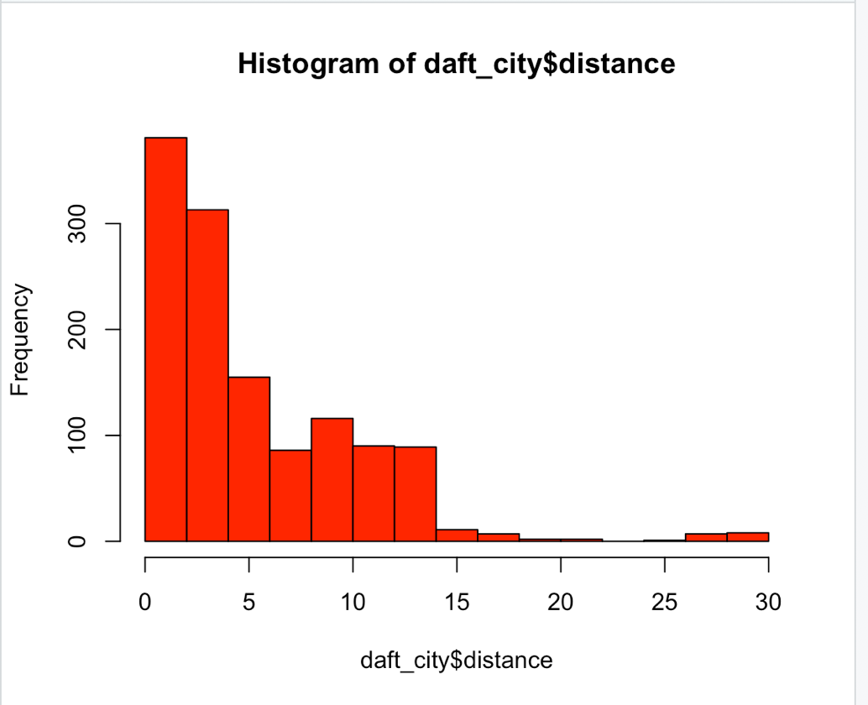

Furthering this analysis, a scatterplot measuring Distance and Price can show if there is any correlation between Price and Distance, Does the price of rent increase as distance increases?

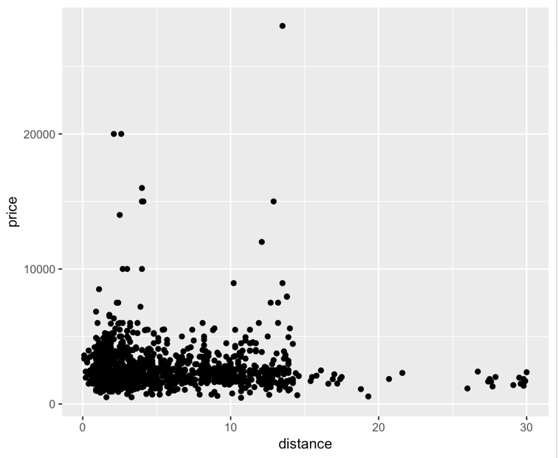

According to the graph, it seems that the monthly rental cost of most listings in the dataset are below 5k. Most of the listings are between 0 and 15 kilometres, which would make sense as this covers most of the city. There is an increase in rent cost as the distance reaches 0, with a few outliers that have massive costs. Again these are the outliers found in the graphs above.

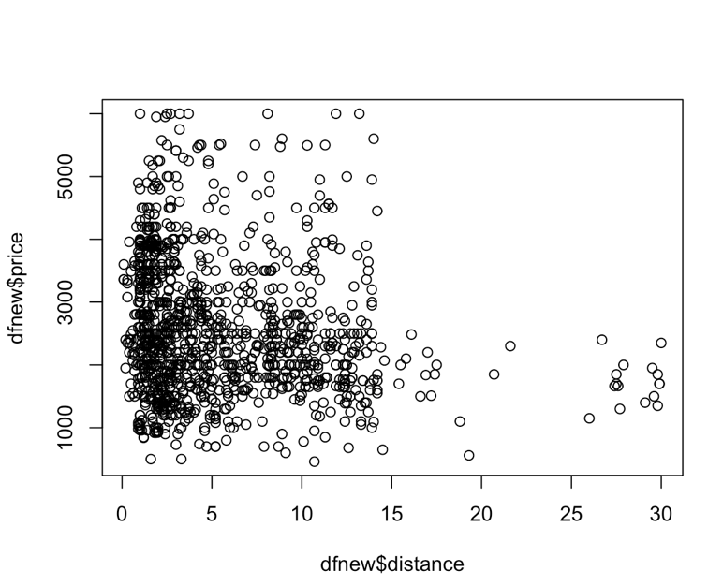

Normalising the data and removing these outliers gives a closer look at the data. It can be seen that there is a large influx of listings between 0 and 5, indicated by the intensity of the black circles. There is also a hard wall at the 15km point, where many listings just don’t rise above a price of €2500.

A boxplot and histogram showing the now normalised price column is shown below.

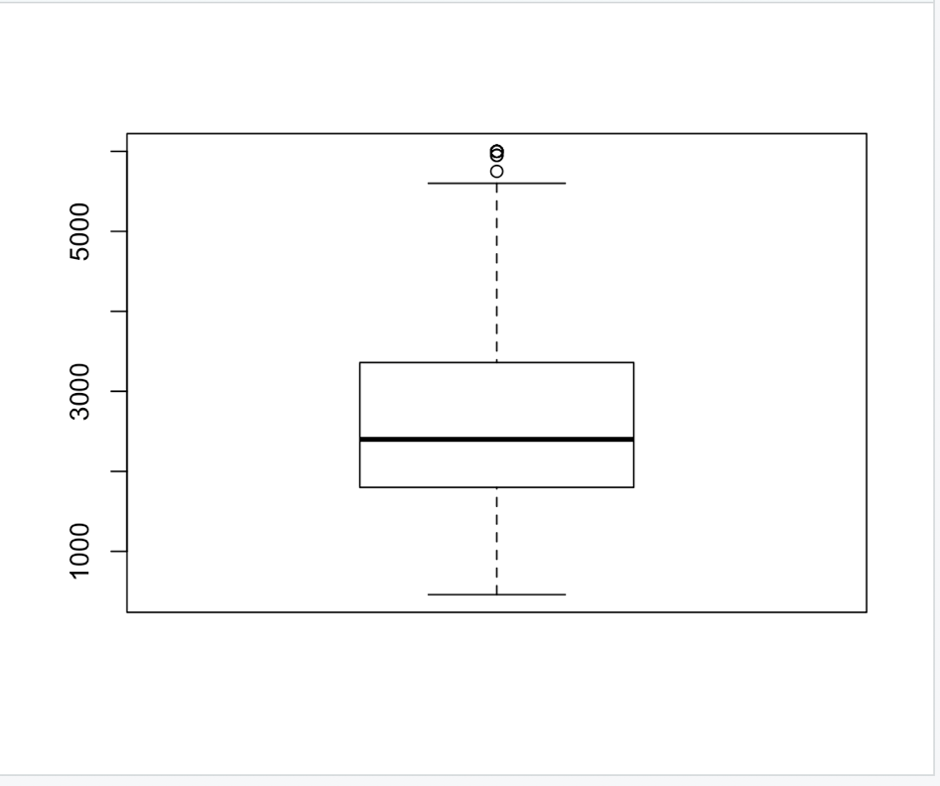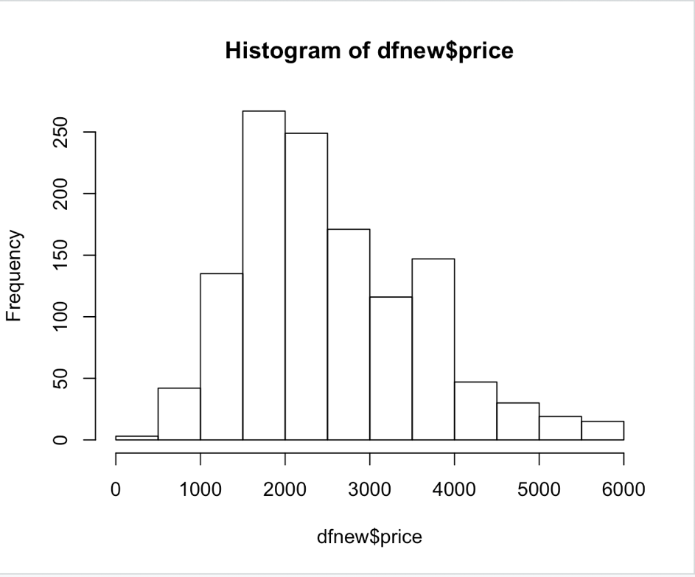

With the outliers removed, the data is more normal and will be easier to fit to a machine learning model.

Looking at dwellings and dwelling types then, a few bar charts were created to get an idea of the distribution of dwelling type across the dataset.

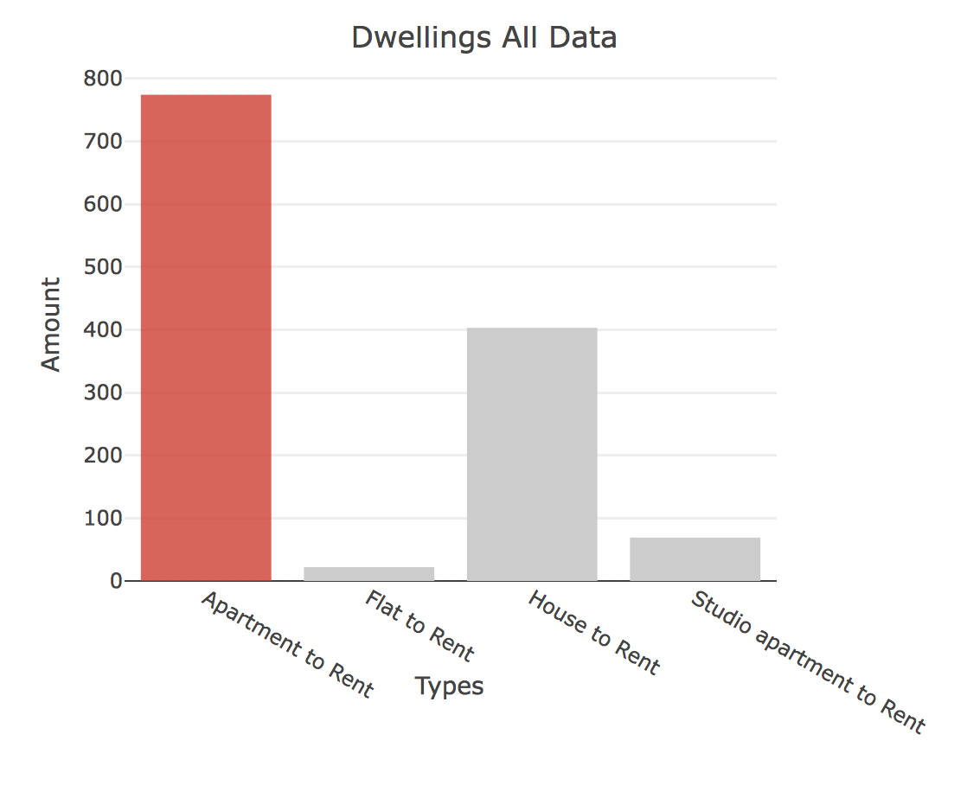

There is a large majority of Apartments for rent in the dataset, with Houses for rent being the second largest category, with flat to rent and studio apartment to rent being a miniscule amount of the dataset.

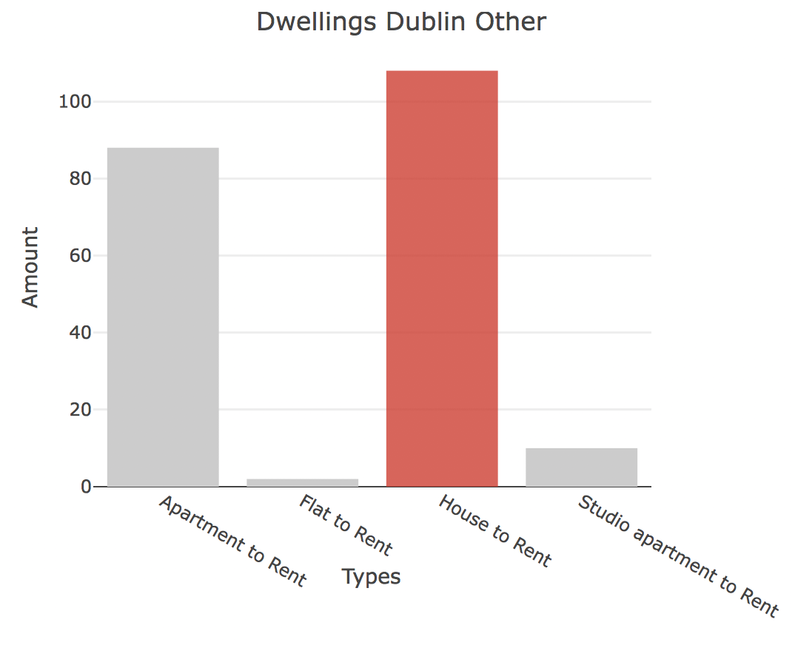

However, areas such as ‘Dublin Other’, which includes all of the listings that aren’t in any of the standard Dublin area codes, such as Dun Laoghaire-Rathdown area to the south-east of Dublin, looking at this area it can be seen that there are more houses available than apartments.

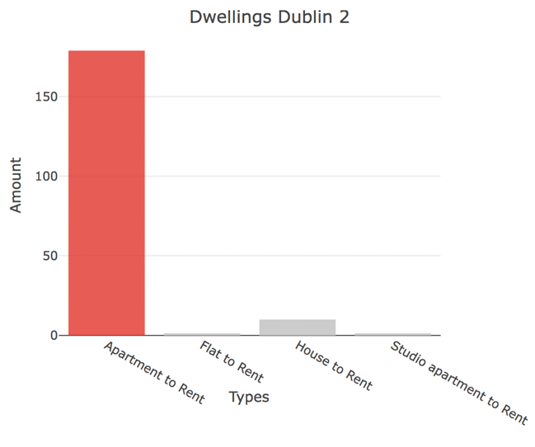

Then looking at Dublin 2, there is an overwhelming majority of Apartments to rent, with very little other dwelling types available in the area.

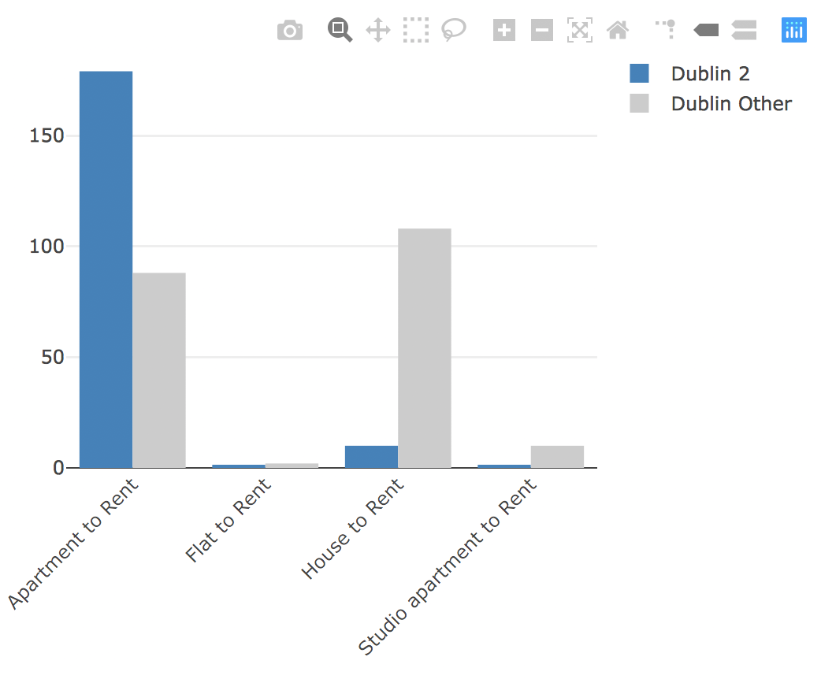

Comparing them directly above.

**North vs South:**

Furthering this point, a comparison between north and south sides of the city would produce interesting results.

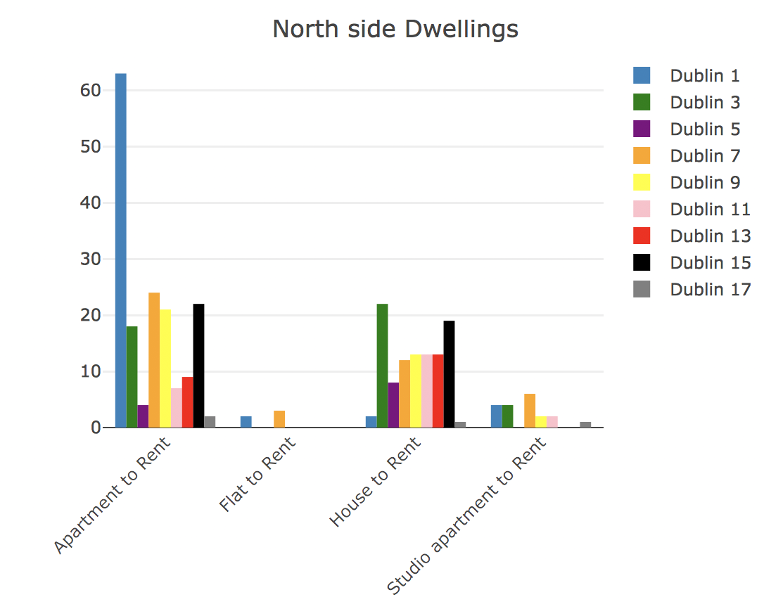

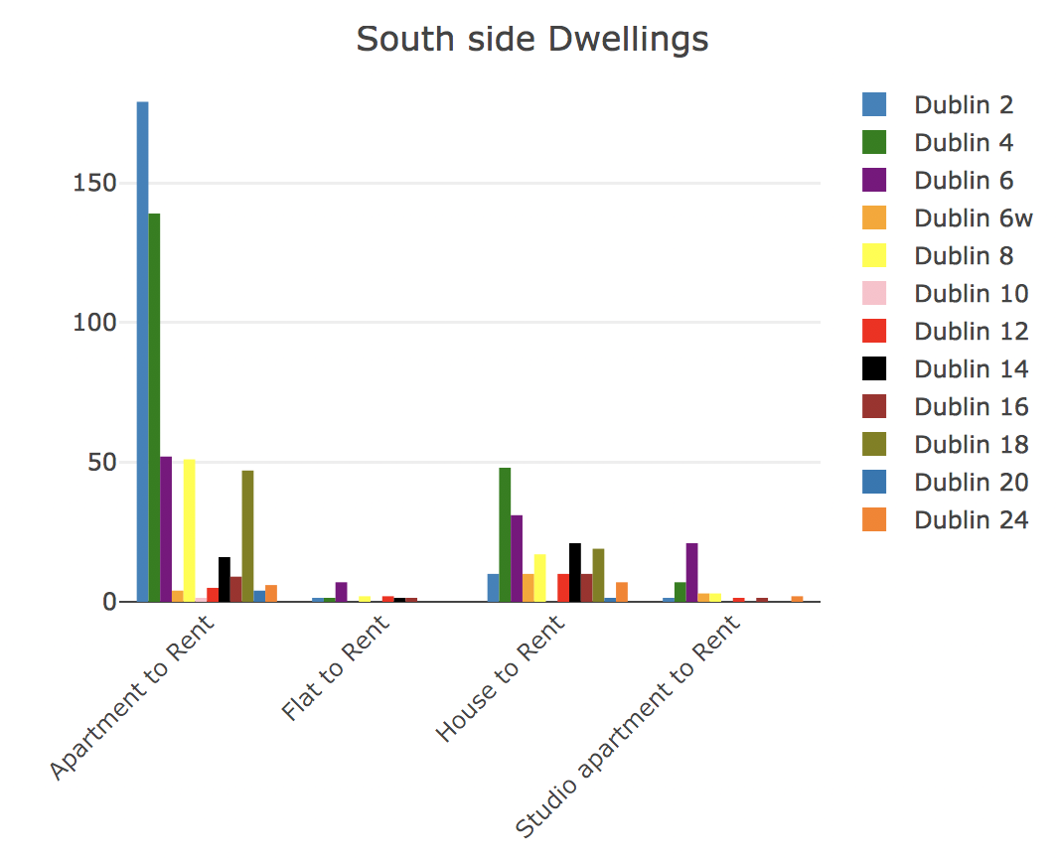

Comparing them to their North / South counterparts showed that the closer an area is to the city centre, the more listings it has. Furthermore, the closer to the city centre an area is, the more likely there is to be houses available instead of apartments.

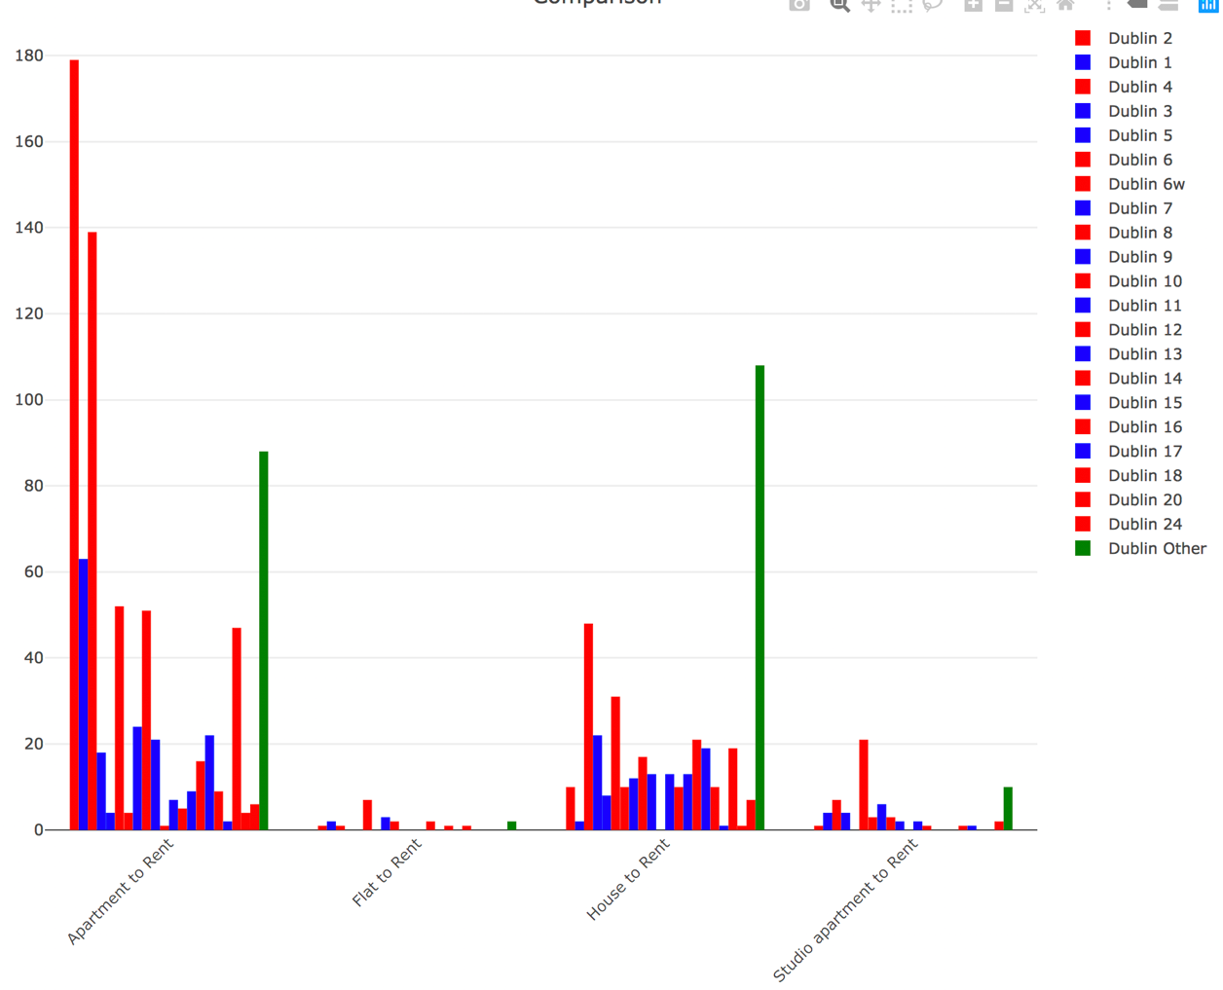

The final bar chart above is a combination of all areas compared to each other, Areas south of the city are highlighted in Red, while North side are highlighted in Blue. The green bar is the “other” category, which includes listings from the outskirts of the city, either far north or far south of the city.

Evidently, it can be seen that there are a lot more south side listings than north side listings, in nearly every category, but especially in the amount of Apartments to rent. The green bars show that there are a lot of listings in the “Other” areas of the city. This is to be expected as there are more single listings in other than in any single area code, as it is made up of many non-postcode listings. However, even here we can see the preference for Houses to rent the further out form the city centre.

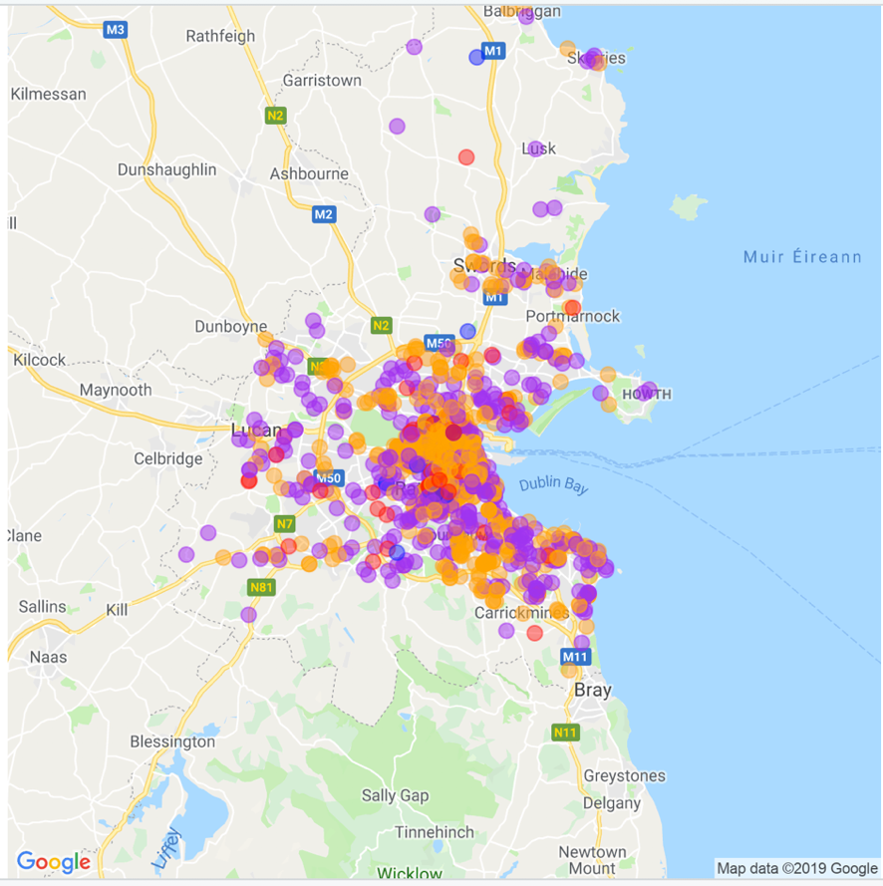

This map shows the distribution of listings, each circle is a listing and its colour indicated its type. Orange for Apartments, Purple for Houses, Red for Flats and Blue for Studio apartments. Again this confirms that further away from the city centre there are more houses, seen by the clusters of purple, and that the city centre is mostly apartments, seen by the cluster of Orange in the centre.

**Average | Median | Mode:**

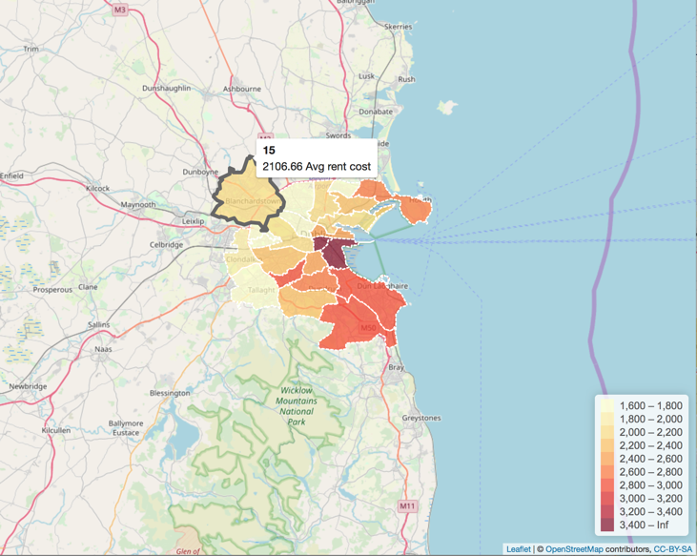

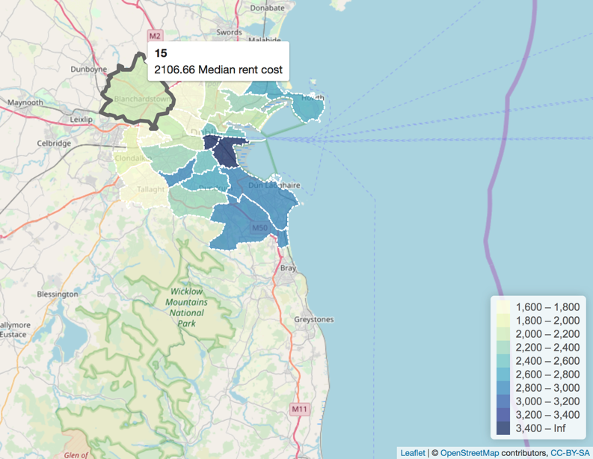

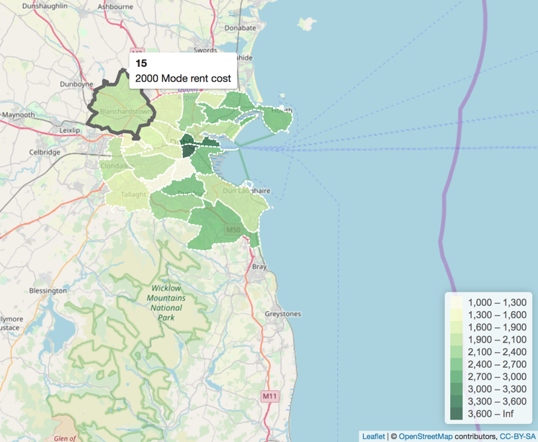

The graphs above is Dublin city split into its separate postcodes, all three interactable graphs where a user can hover over an area and see its mean/median/mode rent cost in that area, and which area of the city it is. Dublin 2, Dublin 24, etc. The areas fade from lighter colour to darker colour to indicate a rise in rent cost, as indicated by the legend in the bottom right hand. This shows us that the data is consistent across mean/median/mode, which is good because it shows that there isn’t one major outlier skewing the data. The Green map, which indicated the Mode is only slightly different from the other two maps, which indicate in some areas, although the average rent price may be high, the actual price that most people are paying, the most common rent price across all the listings in the area is lower.

The map below shows the same information however on a listing by listing basis, the few listings coloured in blue are of a price of 1k or lower, the listings in orange being 1k – 2k, and the remaining red listings, which are a majority of the data points, are anything higher than 2k.

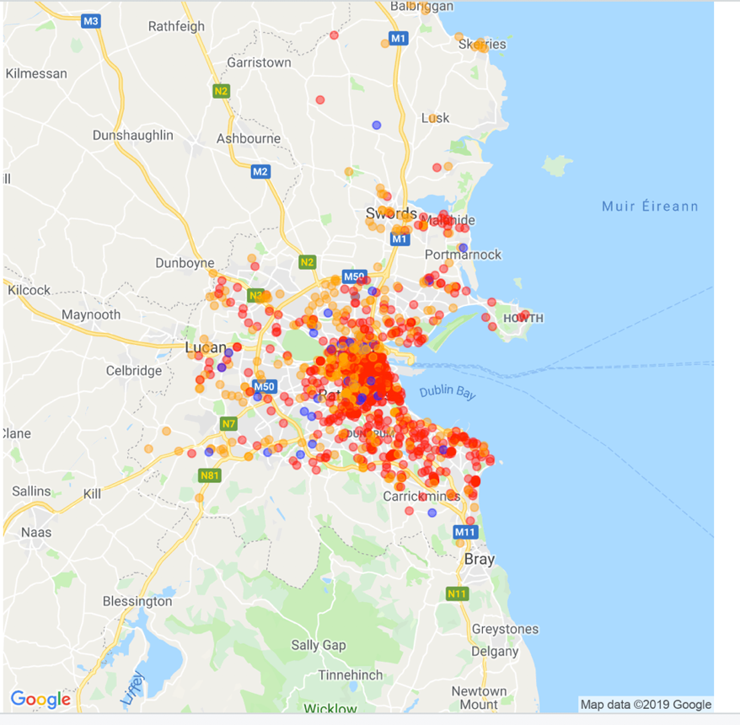

### Data Mining algorithms

**Multiple Linear Regression:**

The data was fitted to a multiple linear regression model, removing non-numerical features and checking for multi-collinearity.

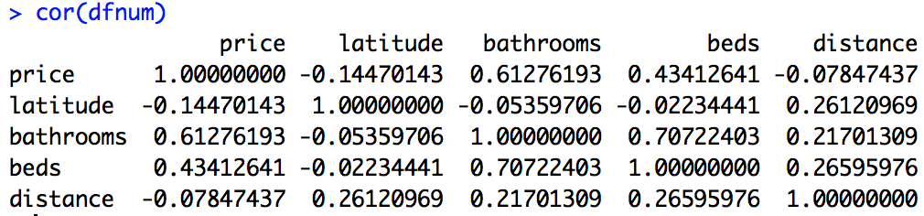

There was only a high correlation between bathrooms and beds.

This initial regression model gave a multiple R-squared value of 0.5249, which accounts means the model is 52% accurate at predicting rent cost, given the other variables.

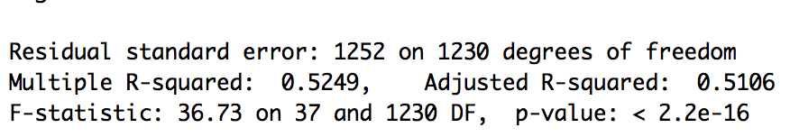

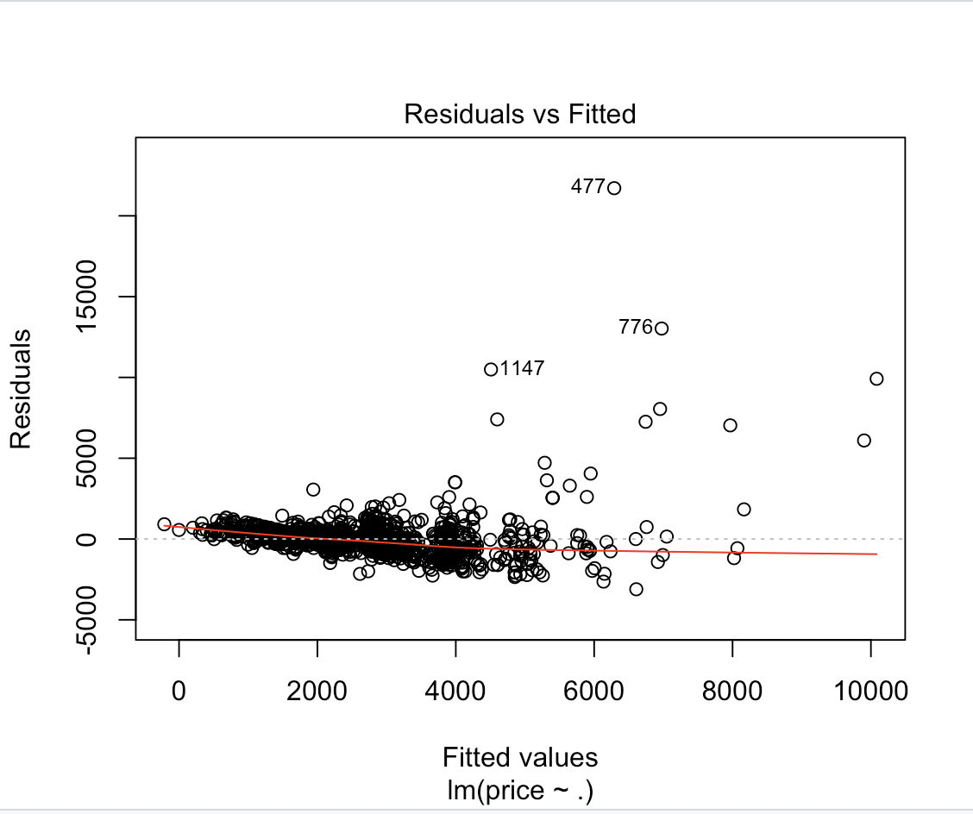

However, this result could be improved substantially. Using the Caret library, A K-fold cross validation method was attempted, which would split the data into 10 sets of training / test data, and then fit the data to a multiple linear regression model 10 different times, and average the results. For additional accuracy, the Multi-collinearity between the beds and bathroom features was addressed by removing one of the two features, the data in the price feature was not normal, confirmed by a Shapiro-Wilk test, outliers were then removed to normalise the data for better predictions, and finally a new predictive feature was added, a listings postcode.

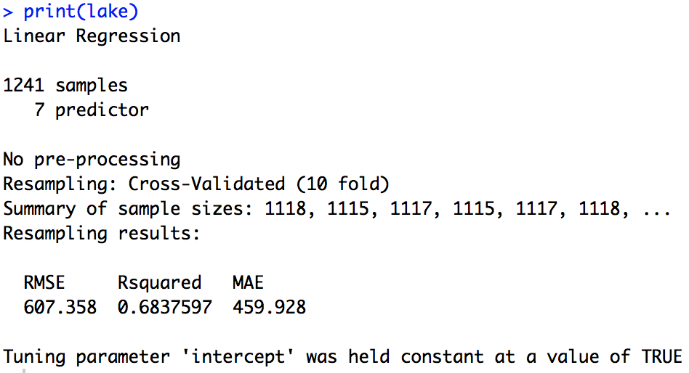

The results of the linear regression model, using k-fold cross validation are above. The usage of k-fold validation, along with the additional changes to the model improved the R-squared value to 0.6837597, or 68% accuracy when making predictions.

**Random Forest:**

The downside of Multiple Linear regression is that it refuses to handle certain data types, which in turn can lead to inaccurate predictions, so the data was also fitted to a Random Forest model, again using K-fold cross validation and the Caret package.

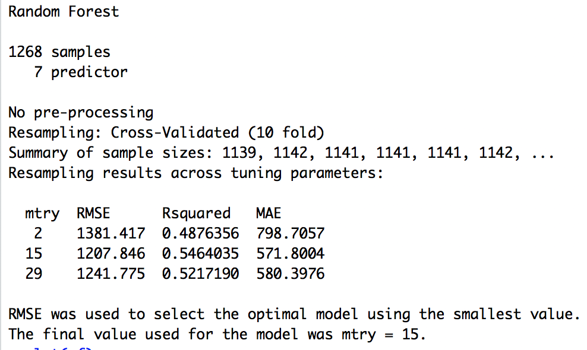

Unfortunately the Random Forest model wasn’t stronger than the Multiple Linear regression model with only an Rsquared value of 0.5464035, however this confirms that multiple linear regression was the right choice of model for this particular set of data.

**K-means clustering**

K-means clustering was performed to try and find any underlying structures in the dataset. First a K of 2 was used to find 2 clusters in the underlying dataset.

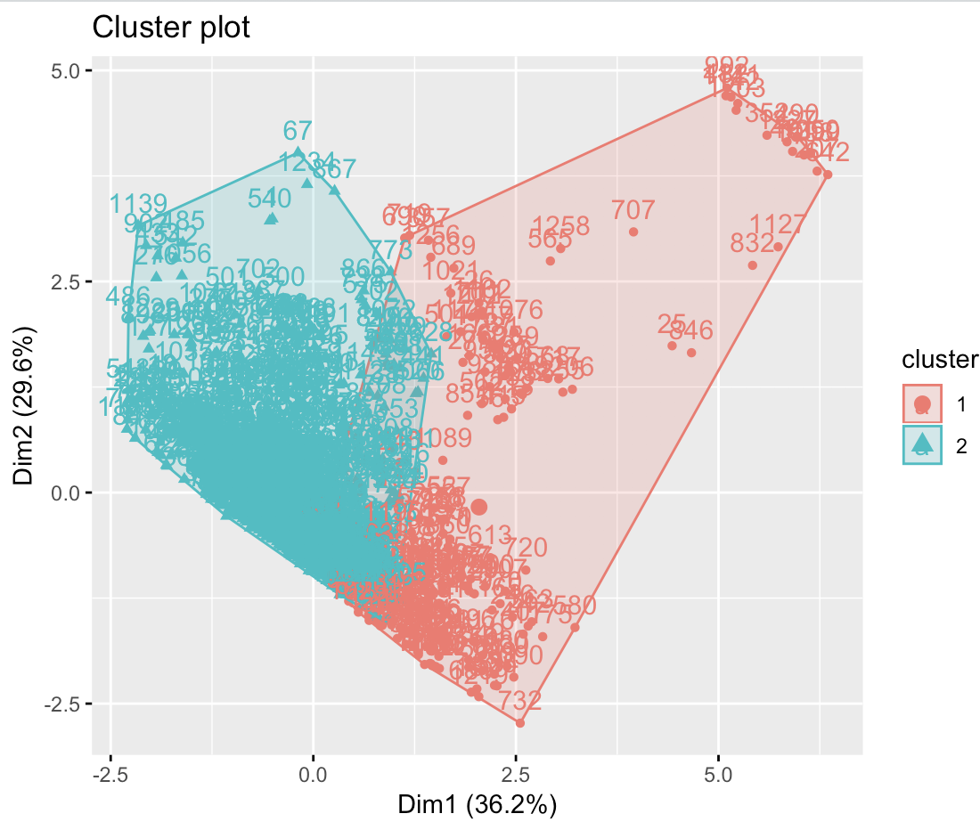

Then multiple plots were created with different values of K.

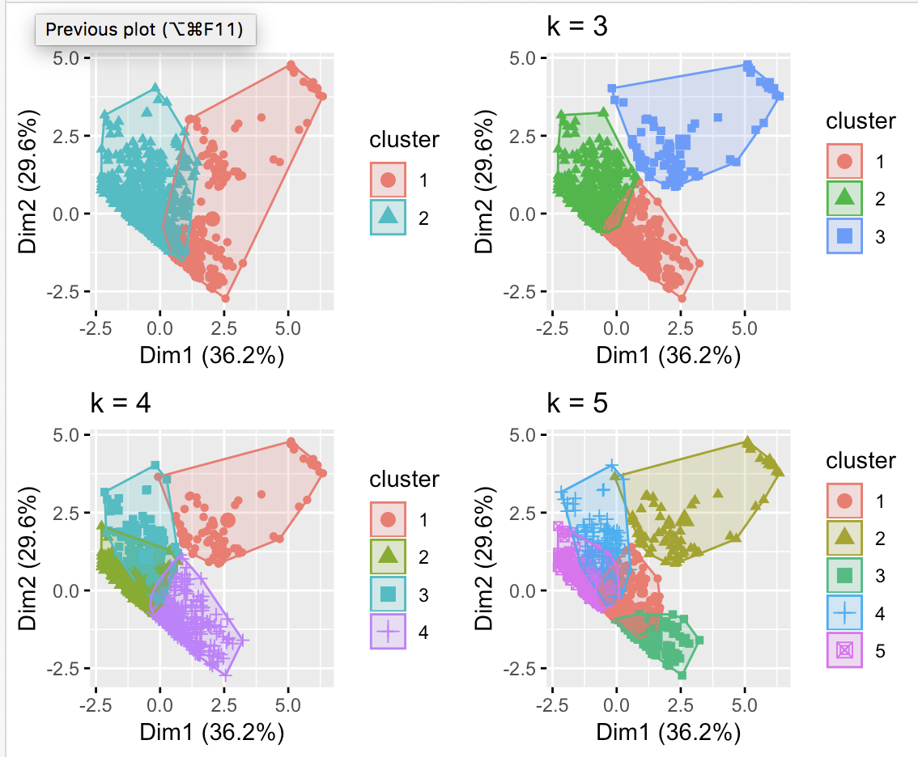

Elbow plots were created to find the optimal value for K, eventually a value of 3 was chosen.

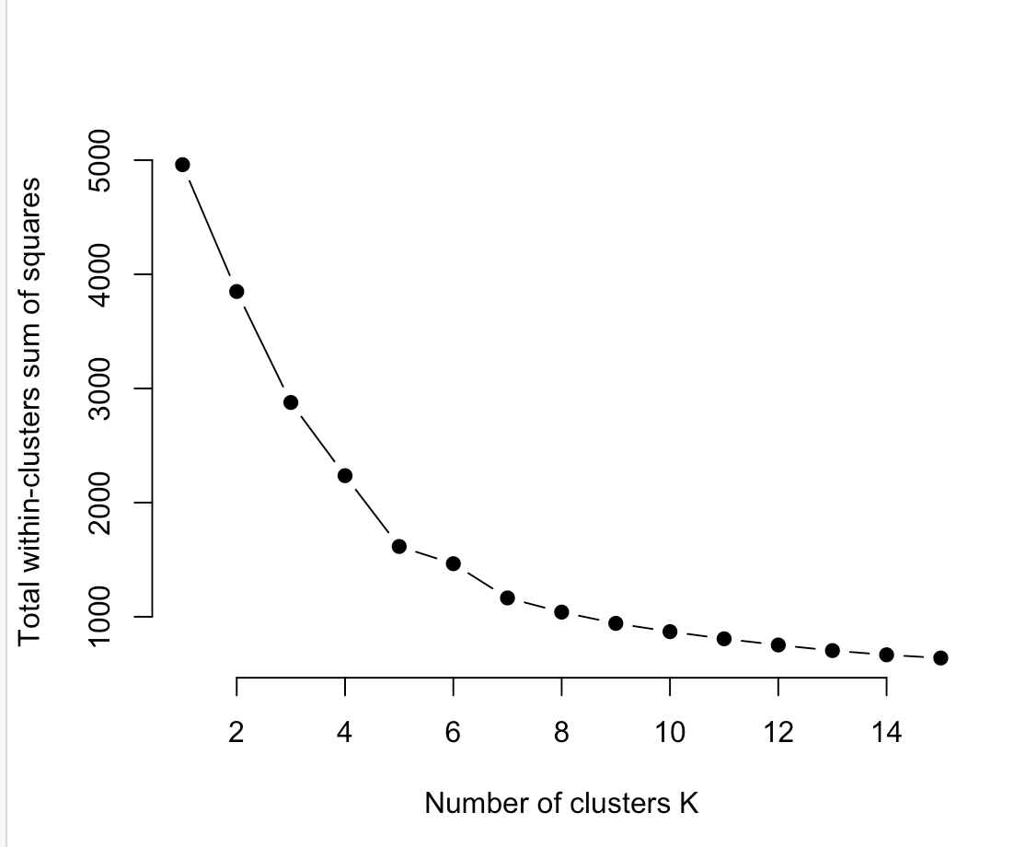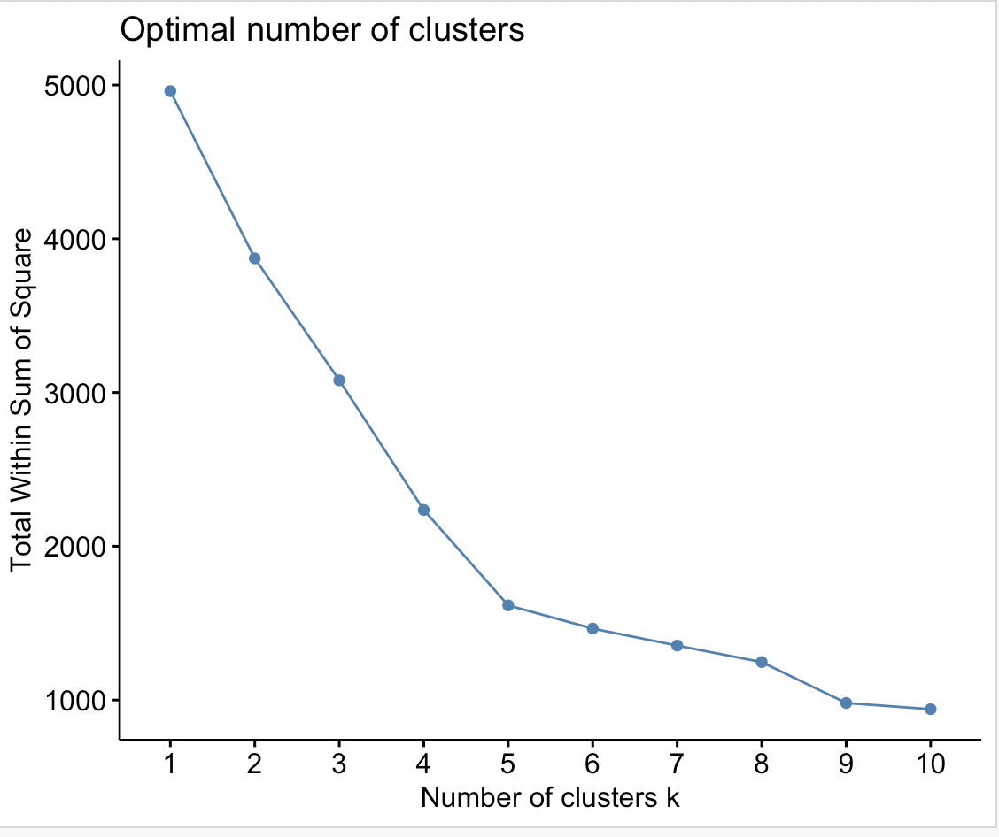

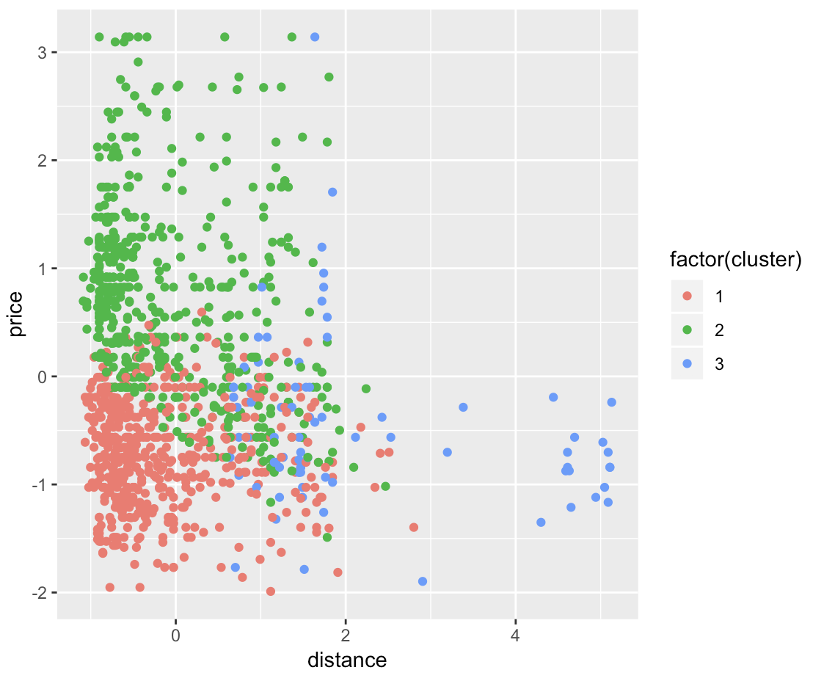

Looking at the graph, there can be seen 3 distinct clusters. The blue clusters are all listings that are far away from the city centre, the red cluster is all the listings that are close to the city centre, although in the lower half of the price range, probably under the median price range of 2500. The final cluster being the green cluster, which is the high cost listings in the city centre, with a cost higher than the median cost of 2500.

## Rshiny Web Front End.

Mock of the ideal visualisation retrieved from this data analysis project.

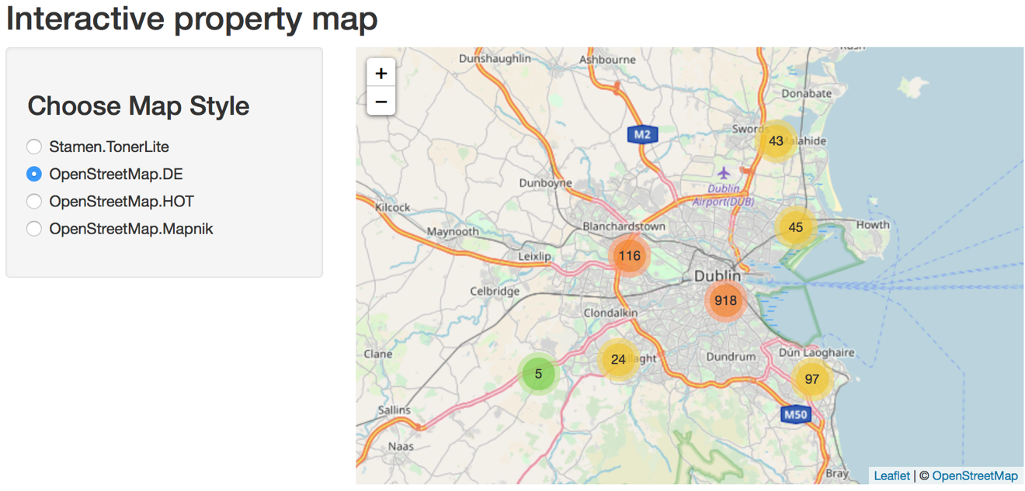

Finally, An interactive property map was created using the Rshiny Library for Rstudio. This interactive map allows users to go in and select different areas, each circle opens up to smaller circles until eventually narrowing down to the individual markers, which display the address, postcode, rent price, dwelling type, and a link to the daft.ie listing which the user can click to then go and contact the owner for a viewing.

## Testing

Inside of the Python Daft API comes a set of unit tests that can be ran in the terminal to test each endpoint of the API and confirm if they are working. It became part of the workflow to run this suite of tests whenever data was being extracted from the API. Executing the tests.py file through the terminal runs the tests, and if anything is found to be broken, the tests will print into the terminal. If the tests pass and nothing is found, the test will return nothing, as the tests have been correctly performed.

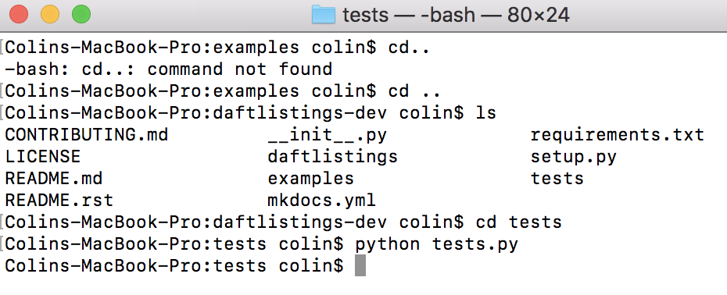

Furthering that, statistical tests were performed. A Shapiro-Wilk test for normality was performed on the price column. This resulted in a very low P-value, which meant an rejection of the null hypothesis that the data is normal, in favour of the alternative hypothesis that the data is not normal.

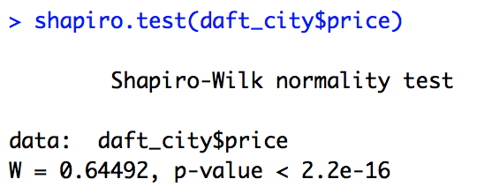

Outliers were then removed to try and normalise the data, however it was important to check that the data was not statistically different, as this would be changing the underlying data. To test for this a Wilcoxon-Rank test was performed to test if the data was statistically different or not.

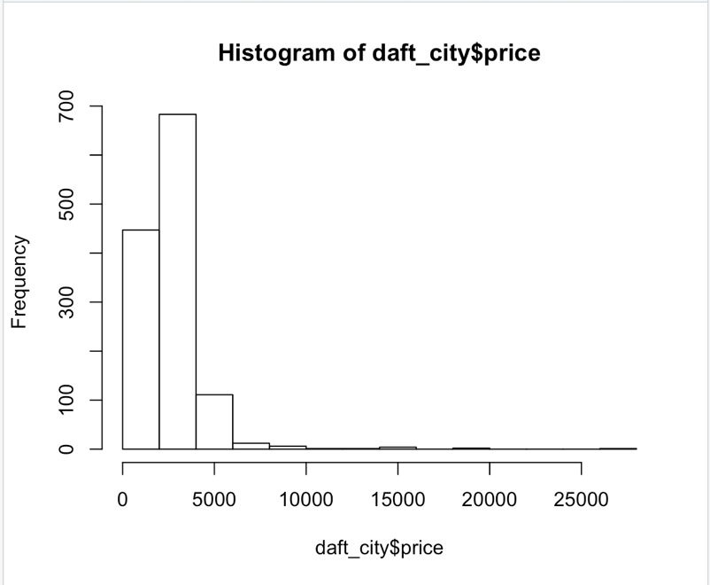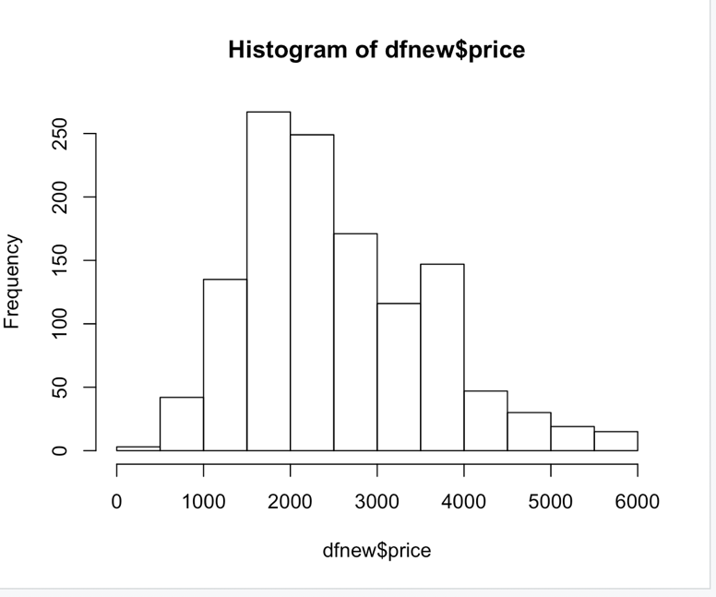

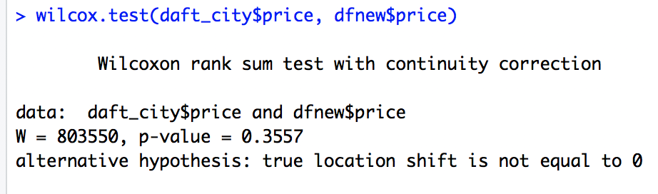

With a p-value of 0.3557, the P value is higher than the alpha value of 0.05, and therefore the null hypothesis that there is no significant difference between the two samples cannot be rejected. Therefore, although the data was changed to be more normal, it did not have a significant statistical effect on the underlying data.

**Evaluation**

Evaluating the work done through this project, the work accomplished was acceptable, a deep look into the Dublin rental market was achieved and allowed a better understanding of what is available to entrants into the market and the distribution of properties across the city.

Implementing machine learning models and making predictions on the data was the most challenging aspect of this project, but elevated the project from simple analysis to something a lot stronger.

**Future work**

Work in the future could allow for deeper analysis along with collection of more data, which would give a better understanding of the underlying effects of the market.

**Poster:**



# References

1. PICS: These Graphs Showing All Dublin Rent Prices For July/August Is Actually Disgusting - Lovin Dublin. 2018. PICS: These Graphs Showing All Dublin Rent Prices For July/August Is Actually Disgusting - Lovin Dublin. [ONLINE] Available at: <https://lovindublin.com/dublin/dublin-rent-august-graphs>. [Accessed 13 December 2018].
2. Python.org. (2018). Welcome to Python.org. [online] Available at: <https://www.python.org/> [Accessed 12 Nov. 2018].
3. MySQL :: MySQL 5.7 Reference Manual :: 1.3.1 What is MySQL? Dev.mysql.com. (2017). MySQL :: MySQL 5.7 Reference Manual :: 1.3.1 What is MySQL?. [online] Available at: [https://dev.mysql.com/doc/refman/5.7/en/what-is-mysql.html](pics:%20These%20Graphs%20Showing%20All%20Dublin%20Rent%20Prices%20For%20July/August%20Is%20Actually%20Disgusting%20-%20Lovin%20Dublin.%202018.%20PICS:%20These%20Graphs%20Showing%20All%20Dublin%20Rent%20Prices%20For%20July/August%20Is%20Actually%20Disgusting%20-%20Lovin%20Dublin.%20%5bONLINE%5d%20Available%20at:%20https://lovindublin.com/dublin/dublin-rent-august-graphs.%20%5bAccessed%2013%20December%202018%5d.) [Accessed 10 Dec. 2018].
4. R:The R Project for Statistical ComputingR-project.org. (2018). R: The R Project for Statistical Computing. [online] Available at: <https://www.r-project.org/> [Accessed 12 Dec. 2018]
5. GitHub. 2018. GitHub - AnthonyBloomer/daftlistings: A library that enables programmatic interaction with daft.ie. Daft.ie has nationwide coverage and contains about 80% of the total available properties in Ireland.. [ONLINE] Available at: <https://github.com/AnthonyBloomer/daftlistings>. [Accessed 13 December 2018].
6. Shawndra.pbworks.com. (2018). [online] Available at: http://shawndra.pbworks.com/f/The%20KDD%20process%20for%20extracting%20useful%20knowledge%20from%20volumes%20of%20data.pdf [Accessed 12 Dec. 2018].